A Big RE day
5 possible ways in to the content of a ‘Big RE day’
- Getting creative with creation: a day of music, drama and arts work that uses the wonder of the natural world, creation stories from Genesis, Hindu tradition or the Qur’an and arguments about our origins (accident or plan of love?) to explore the question: does a beautiful world mean there must be a wonderful God?
- Debating the hot ones. Use methods like ‘philosophy for children’ to explore big questions with pupils in the morning so that they can run a really exciting and well thought out formal debate that involves everyone in an afternoon session.
- Inspirational leaders: choose your hero. A day to focus on Gandhi, the Prophet Muhammad, Jesus, Dr King, Jackie Pullinger, Mother Teresa or Aung San Suu Kyi, asking pupils: who do you most admire and why? Mix discovery, biography, movie clips and dilemmas with young people’s own ideas, reactions and views.
- Global citizenship: Exploring the problems of inequality and poverty, and finding out how a charity like Islamic Relief or Christian Aid makes a difference for those whose lives are damaged by AIDS, war, famine or big business.
- Easter: did he really? Set up an experiential set of reflective ‘stations’ that tell the story of Maundy Thursday, Good Friday and Easter Sunday. Explore the experience through story, drama, music, drawing, poems and reflection. Get pupils to create their own drama or speaking performances on the human themes of betrayal, loneliness, suffering, despair and hope.
(or a Big RE week)
Organising the RE curriculum for high impact

This guidance provides a rationale, some planning ideas, and good examples of innovative ways of delivering RE in creative curriculum structures such as a whole planned day or a week of cross curricular learning with an RE theme.

Good religious education doesn’t need to be bound by rules about ‘one lesson a week’. Too often, the subject is given low status by teachers, so pupils don’t take it very seriously. Signs of this status problem include being taught mostly or only in PPA time (HLTAs can do a great job there, but teachers should take responsibility), or ‘ten in the bed’ syndrome, where when the subjects ‘roll over’, it is always RE that ‘falls out’. In some schools which claim to be doing an hour a week of RE, many classes actually do 20 minutes at the end of a long day.

One way of raising the status of the subject is to run RE days that give pupils an intense experience of RE over a short period, or an RE week, where the whole curriculum is organised around an RE theme for a longer period. These kind of events are popular where creative curriculum planning is in place, and both teachers and learners enjoy this kind of approach. In a whole day experience for pupils, excellent learning can lead to deep thinking, time for creative RE, real opportunities for spiritual development for pupils and new perceptions of RE for all.

Presently, both primary and secondary schools are supposed to be making their curriculum more flexible and they run whole day experiences from groups of pupils on business and enterprise, drama and the arts, experimental science, sport and even maths. So why not RE? Actually, lots of schools are willing to run an RE day. This article gives you five starter ideas for topics to think about (in the blue box to the right), and some ready to use lesson idea (adaptable for different topics) on the pages that follow.

The aims of the RE day
Be clear that a day experience like this is for pupils’ learning and spiritual development. Plan to focus on the religious educational aims of your work first. Sometimes it is good to have a cross-age focus for the day, a whole school impact in a week – but good RE is only served if aims are clearly RE and clearly met. Step one in planning is to set aims for learning about religion and learning from religion in terms that all pupils can achieve.

These four areas might provide a shell for setting your aims:

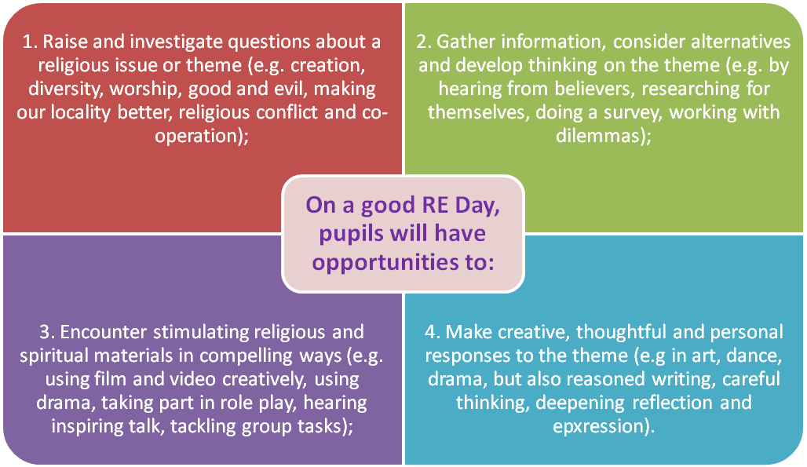

In the examples given later in this article, setting aims that were challenging and realistic were key in the success of the venture. Helping children to respond for themselves, rather than gather more information and facts is the key to success.
Sample activities:
Big Questions: 20 prompts for ‘paper the walls...’
- I wonder if...
- I’d like to ask God...
- The biggest mystery to me is...
- Humans will always argue about...
- I really disagree with...
- If God is real then...
- If there’s no God, then how...
- I believe in...
- I don’t believe in...
- When we die, I think...
- After we’re dead, I think...
- If I could see the future, I’d look for...
- If I could visit the past, I’d like to...
- There must be a devil because...
- There can’t be a loving God because...
- There’s no devil because...
- We’ll never know...
- If Jesus came back, I think he would...
- Why...
- And another thing I’d like to say is...

Debating ultimate questions: ready to start
This example is aimed at upper primary and secondary pupils, but the three learning structures are adaptable for 7 year olds and any age group. They work well: give them a try. The important thing is to enable curiosity to lead to enquiry, investigation and discovery.

Part 1: Paper the walls with you wisdom
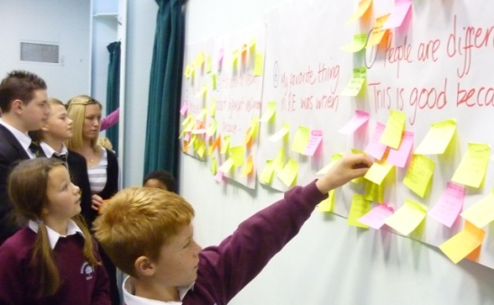
From the 5 suggestions in the box, here’s one in a ‘ready to use’ format. Take 20 prompts such as those in the red box, and write each one in the centre of a big piece of flipchart paper. Give pupils 7 post it notes each as they begin the RE day, and tell them they will be asking the biggest questions of all today. They choose seven prompts they find interesting and note their numbers on the post-its, then finish the sentences however they want to. Ask them to be witty – but ask for wisdom and big ideas too. This approach enables them to set the agenda for an enquiry into the meaning and purpose of life and place of faith. If 30 pupils do seven each, you will get 210 ideas and comments in 15 minutes. If a larger group work on this, then you can get 500+ ideas. Ask groups of pupils to take one sheet of the ideas and pick out what is typical, interesting, surprising and fun to report back to the class.
Part 2: Everybody up: stay standing if...
This bit of theatrical learning owes a lot to Graham Norton. It’s great for encouraging spoken participation in a big crowd, and making everyone feel they are part of the programme. Ask the audience to all stand, then stay standing if they’ve ever...
...seen an animal die? (talk about Hindu reverence for all life)
...been surprised by someone taking religion very seriously? (talk about commitment and its signs in different faiths)
...changed their mind about a belief? (talk about conversion)
...felt that God was near to them? (talk about religious experience in different traditions)
...had a premonition that came true? (talk about scriptural accounts of visions, dreams of prophecies)
...had an experience that showed them what happens after death? (talk about
Run round the room with a real or pretend microphone asking questions of those who stay standing. You’ll be amazed: they will talk, laugh and think loads. Feed in big religious ideas and questions as you go.

Part 3: bring it together with questions: linking experience and que stions
Give every pair in the group one of the ‘paper the walls’ sheets to review and report back upon, and three huge fill-in question marks. Ask them to fill the question marks with what they’d like to have answered about the topics they considered. The following week, answer all their questions (well, make an honest failure out of the attempt anyway).
Dos and don’ts – nine ways to make your RE day memorable:

- Beyond entertainment to being thought provoking
First, if you think and plan carefully what the children will remember from your day’s work, then you have a good chance of enabling good learning too – but this doesn’t happen automatically. Sometimes at the end of the day the children have been entertained and had fun. But this is not sufficient: did the day enable the RE aims to be met? This intention should lead to some well structured written work and some purposeful group thinking being built into the day plans.

- Never talk for long: break the programme into dynamic, creative chunks
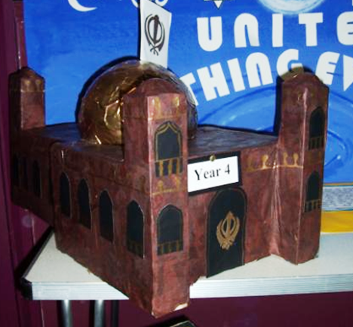
Second, you need to timetable short sessions. Don’t be boring. I never speak for more than 12 minutes at a time to a group on an RE day – it’s one of my most useful rules – but 6 might be even better. Interactive learning is essential, and you must trust the young people to learn through the activities you set up. A good RE day is not usually a set of lectures, but a set of interactive experiences. If you do have large numbers of pupils working together, then make sure that groups work makes space for active rather than passive thinking. Judgement tasks are especially useful:
In your group:
- Design the new mosque or gurdwara for our town, then plan the opening of the place of worship (how would different faith leaders contribute?).
- Devise adverts (paper? TV? Radio?) that show what is unique about three different religions
- Plan a speech for the candidate for mayor of your town, emphasising how to make peace between communities.
- Write a collection of prayers and meditations for three different festivals which the class have studied, for young children, older children and grown ups.

- Remember that fun + clarity = learning.
This does mean you have to think really carefully about what you say: don’t try to communicate the whole doctrine and history of the Christian tradition or a PhD vision of Islam in Britain and the world in your day. Don’t go over the heads of the audience – it’s not a theological college. But do work out what simple points you want pupils to think about and make sure they are communicated from three or four different angles, making the learning engaging.

- Mix the group size, and make groups purposeful
Always mix small group work with whole group sessions and keep them literally on their toes: moving about with kinaesthetic learning is powerful. My favourites (see previous page) include collecting replies from each child to their choice of six from twenty prompts on the topic. They write their thoughts on post it notes, and ‘paper the walls with their wisdom’. I also like Graham Norton’s ‘Stay standing if...’ routine: he asks his audience to all stand, then stay standing if they’ve had an amusing experience with a vegetable (whatever). He runs round like a demented elf with a microphone, and people share their too-intimate secrets. I suggest slightly different experiences, but the strategy is amazing.

- Visitors can energise learning: a community asset for RE
Do invite the local faith communities to send some visitors. They can work alongside pupils, answer questions, share experience and contribute authentic voices. Often asking a visitor for an assembly or lesson is too brief, and therefore unsatisfactory. An RE day can be a much more useful encounter with people of faith. Include your visitors in your planning wherever possible.

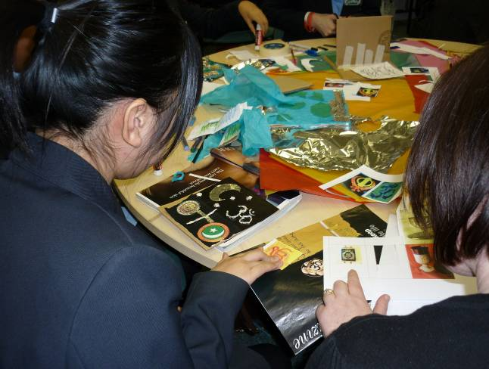
- Imaginative and creative learning doesn’t fail
Lastly, it always works to make your day creative. Whether pupils make a collaborative collage of images of heaven, speak a piece of their poetry to camera, rewrite a Bible story into 21st century Bognor or dance the body language of the Lord’s Prayer, make sure that you give time and space to their creativity. Teachers have planned examples where pupils work together to:
- Create a dance routine to go with a piece of religious music;
- make a cardboard model of their perfect street for the future of their town, complete with 6 different religious buildings;
- Take a set of 8 photos from the visit to a Church or Mosque, and put them into PowerPoint. Ask pupils to add captions and both speech and thought bubbles to the people in the pictures, as a way of recounting what they learned from a visit.
- express their sense of rage at the evil in the world, then their sense of hope;
- consider what gets crucified in today’s world, in the light of learning about the death of Jesus;
- develop and illustrate six arguments for and against belief in life after death.
- In teams, make a seven piece collage of the ‘days’ of creation from Genesis chapter 1, or a ‘Then and Now’ display about Jewish celebrations at Pesach / Passover, where different groups of children each contribute a ‘panel’ to a bigger display.

- Go in with a bang and go out with a bang
Try and make the day different from the beginning - that could small scale such starting with a whole school assembly introducing the theme with drama, visitor or video or arranging the classroom differently. It could be larger scale with teachers dressed as inspirational characters or walking around the playground protesting at a perceived injustice.
A shared outcome for the day gives children a focus and a reason for you to invite in parents, governors and press. It is important that the whole day is not spent ‘polishing’ a performance the day is about having time to engage more deeply with material.

- Consider a carousel
A series of activities investigating the same topic for children to engage with. This is particularly useful if you have visitors in for the day. It is important that the children are given the opportunity to reflect on the experiences they have and that there is progression.

- Mix group sizes and ages
For many children it can be refreshing to work in different grouping perhaps pairing different age classes for part of the day or allowing children an element of choice that will lead to different groupings. Other school ways of organising such as houses can be used to create groups for the day.

Always mix small group work with whole group sessions and keep them literally on their toes: moving about with kinaesthetic learning is powerful. The examples in this article show these kinaesthetic ideas in action.

Your plans will go wrong.
A day like this will never be perfect. You will be disappointed that your aims for spiritual profundity seemed to be overwhelmed by childish silliness or adolescent indifference. But if you are just starting on creative curriculum RE days, learn from what goes wrong, and keep at it. Ruthless self criticism will make things better next time, and it is surprising what learning happens beneath the crust of children making a mess with tissue and glue or the apparent cynicism of teenagers. There is no ‘going wrong’ that is so bad that you can’t learn from it for next time. It applies to running RE days.

Six possible ways of getting into the content of an RE big day
Getting creative with creation  A day of music, drama and arts work that uses the wonder of the natural world ,creation stories from Genesis, Hindu tradition or the Qur’an  - Why do people want to know how the world came into being- what are some of the different ideas  - Why do religions have narratives that try to explain the beginning of the world  - Write poetry and create art interpreting the pupils questions about the world around them  - explore the question-  Does a beautiful world mean there must be a wonderful God? | Where are all the heroes?  Inspirational leaders-choose your hero  A day to focus on Gandhi, the Prophet Muhammad, Jesus, Dr King, Jackie Pullinger, Mother Teresa or Aung San Suu Kyi or a local religious figure that inspires.  - Asking pupils: who do you most admire and why?  - Mix discovery, biography, movie clips and dilemmas with young people’s own ideas, reactions and views.  - Use a guided visualisation technique to focus on the wisdom shown by inspirational people  - Each class could take on a different person and create a different outcome; a drama, a film, a poem, a piece of art  - Share results on the school website, in a gallery or presentation for parents or in a display at the local library.
Big Questions  Use methods like ‘philosophy for children’ to explore big questions with pupils in the morning so that they can run a really exciting and well thought out formal debate that involves everyone in an afternoon session.  - Get the children to choose the questions that niggle or interest them  - Will I know all the answers when I die?  - If there is a God why is there poverty?  - Invite in people from two different religions to express their own ideas about the questions  - Explore what people do about their beliefs? What do the sacred texts have to say? | Global citizenship  Exploring the problems of inequality and poverty, and finding out how a charity like Islamic Relief or Christian Aid makes a difference for those whose lives are damaged by war, famine or big business.  - Pupils could do web based research, or invite visitors to come and share information about the charity.  - They could devise TV ads for the charity, inviting donations and publicising the work. Could they dramatise these, or videotape them?  - Run a role play in which some children take the role of grant applicants to the charity and others are the grant allocations committee.
Easter: did he really?  Set up an experiential set of reflective ‘stations’ that tell the story of Maundy Thursday, Good Friday and Easter Sunday.  - Explore the experience through story, drama, music, drawing, poems and reflection.  - Get pupils to create their own drama or speaking performances on the human themes of betrayal, loneliness, suffering, despair and hope.  - Ask older children to create a 60 second commercial to be shown at Easter entitled Jesus: Why he is / isn’t relevant in this decade? | Why do religions tell stories?  Seek out support from your local library, a storyteller or a theatre group. The whole school could focus on stories from one religion or stories could be used from several religions.  Explore some of the purpose of stories in religions. Why are they told? How are they told and remembered? Do the stories connect to beliefs?  Each group could take a story and study it, perhaps finding a way of presenting its meaning in a fresh way for others to understand, using drama, art, animation, dance or some other creative process.  Alternatively a group of stories with messages could be looked at and groups could write their own story with a message for their school or community, drawing on a message from one of the religious stories studied.

How to run an RE theme day: Three Examples
- Experience from St Bartholomew’s School, Quorn, Leicestershire
Amanda Moxon shares her experience of strengthening RE through themed days of special work.
Ingredients: boundless enthusiasm, inspiration, energy and vision to see it through to the end!!!
The first need is to choose a theme that will benefit the school, both staff, pupils and the school community. For example we have chosen ‘Respect for all’ as we are a monocultural school, predominantly white and our aim in this week is to open up the minds of the children, parents and staff to the wonderful possibilities of a diverse and multi coloured community, one where we can learn from each other, skills for living and loving.
There are a multitude of possible themes and the children when asked have fantastic ideas. The obvious choices are celebrations, but there has been a lot of work on these in regular RE lessons.
Play to the strengths of individual teachers, but might these themes work for you?
- Peace: perhaps the school has experienced trouble within the community so there is a need to pour oil on troubled water. The school is often at the heart of such issues and can promote peace and tolerance through this message. This could be relevant for racial harmony or disputes between pupils for a variety of reasons. This could include work on trust, and be presented as an ‘Acts of Kindness’ day, in which learning about peace and trust opens the possibility of doing something about it. Themes of community, and questions like: ‘who is my neighbor?’ ‘How can we make peace?’ ‘Why are there wars?’ can be included as a starting point for investigations.
- The Bible: a treasury of stories and wisdom. Tackle one well chosen story per class, giving teachers the choice so that they can play to their own strengths and put their unique stamp on their own class’s work. Pupils might approach the story via literacy activities, hot seating, ‘reflection alley’, diary writing, newspaper, poetry or whatever the literacy curriculum is going with texts. Make sure pupils are encouraged to ‘look for the wisdom in the story’ as they work. Get each class to create a performance piece for the rest of the school to enjoy: this could be drama, singing, music making, poetry – or why not a short film?
- Inspirational people. A week’s work might concentrate on non-fiction and biography in literacy terms while looking first at great ancient leaders such as Moses, Muhammad, Jesus or Guru Nanak, and contrast and compare them with great leaders of more modern times such as William Booth, Nelson Mandela, Dr King or Mother Teresa. Set up the enquiry with questions like ‘What makes a leader?’ Who do you follow? Who or what is inspiring for you?’
- Thankfulness We have just experienced a new build of our school, for which we are truly grateful (and thankful that the work is over!). An RE day might look at how different communities show they are thankful, and encourage those ‘wonder and appreciation’ moments through well planned learning outside the classroom. There are obvious links to festivals like Eid, Sukkot and Harvest, as well as to the regular worship of a faith community. Set up the enquiry process with questions like: Who do we thank? How do we thank? Why do we thank? What do Christians and Jews do to be thankful?
- A Cultural Diversity and Heritage Day. This is good for the start of a new term. We send a relevant task out as homework on the last day of the year for children to return: a ready made display but useful as a class intro and for the class to see who we are, what makes us tick, what we believe, what makes me special and our cultural roots. For us, this kind of work has included looking at green issues, caring for our world, thinking about our school’s values, looking at sayings of Jesus about how we treat each other and exploring each pupil’s family life.

Leading and supporting colleagues. When a date has been set, a staff meeting needs to be organised by the leader of the day to discuss the theme and the possibilities for the day. It is here that the hard work to motivate and enthuse staff takes place and I often find that cakes help with the atmosphere and good will… not a joke! I really believe that if you want something to succeed and succeed well, you need to invest in people at the start.
Planning: involve everyone. All staff need to put a basic plan together from an old fashioned spider diagram and then come up with the ‘I can…’ statements to ensure clear aims and progression, which is vital. It is important for the RE coordinator to make a basic or detailed plans for each teacher to take and personalise to suit. This is often easily put onto the school VLE to adapt. What teachers often need is good, classroom close ideas – things to do. A good subject leader will help with this level of planning by providing good ideas. Invite governors to this process if they are willing and able.
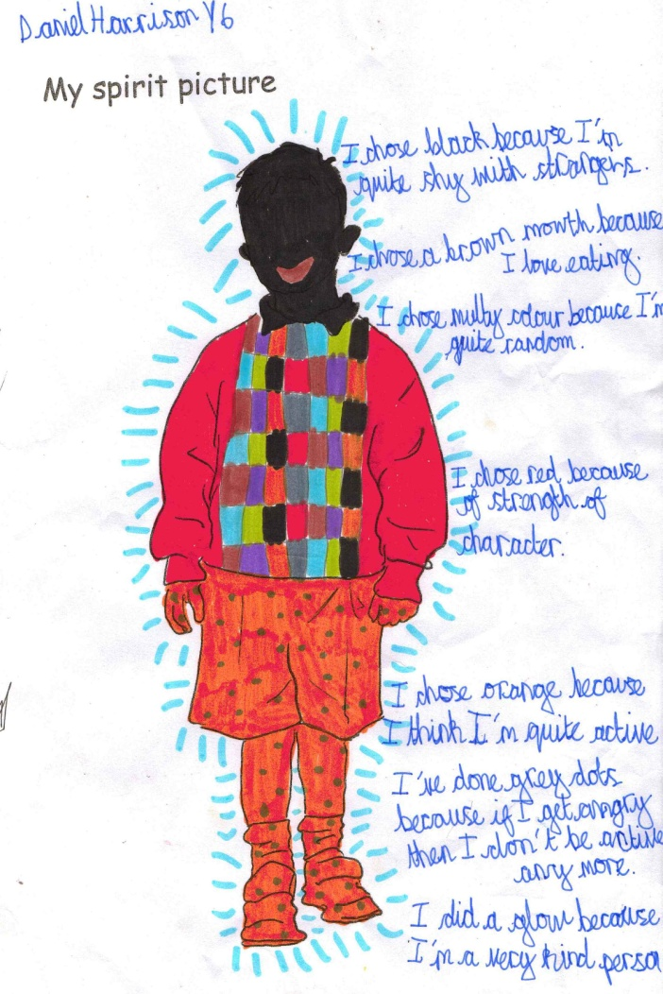
Bringing the school together. On the plans it is often good to have a whole school-unifying task. Here are four which we have used.
- Every pupil makes a self-image, full of the colours they choose to represent their own spirit or self.
- Every pupils symbolises their identity as a jigsaw made up of a number of pieces – four or five for the little ones, but more complex for the older ones.
- Pupils work from a common art or poetry stimulus. This seems to gel everyone together as if all working towards a common goal.
It is lovely to mix up age groups but this is often a huge task logistically. Get the music coordinator on side and plan to learn a song in the weeks before to celebrate with on the day.
Finishing well: We think it is very important to finish these kinds of day with an act of collective worship to share work and experiences, and to make a central piece of display work. We always record the work and the experience with photos and video clips, and learn from mistakes! Pupils from Year 6 can be in charge of the recording of the week in a PowerPoint or other uses of photos. Amanda Moxon

Example 2: Respect for All
An RE week on respect for everyone at All Saints Primary School, Sandwell
All Saints School in Sandwell decided to have a special week of work on RE, with a focus on respect for everyone. They wanted to improve RE in the school, and give all staff a taste of excellence in the subject, so the head teacher Jackie Beech planned half a day of in service training on a teacher day, and set all the classes the challenge of thinking about respect in the local area in RE. Themes of community, faith and identity were addressed in a punchy week of activities in early September.

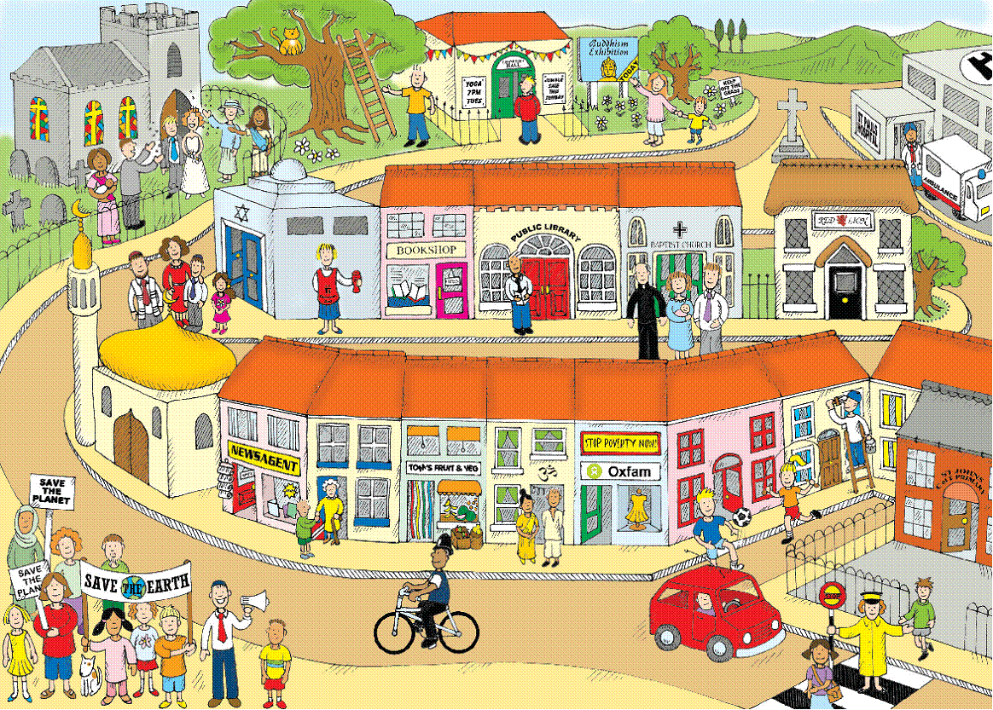
All age work and learning outside the classroom linked with design and thinking skills activities in a creative and dynamic mix. Pupils were involved in collaborative work for a ‘Respect through RE’ week. Different age groups worked, with older children helping younger ones. Early in the week, pupils went out into the local community for a photographic walk. The brief was to find examples of the different concepts, and take photos from the local community to illustrate them. It made the children think and talk as they walked. Concepts for the week included:
- Kindness
- Conflict
- Community
- Faith
- Harmony
- Peace

Lots of pupils created ‘identity images’ for themselves: the teachers wanted to be sure that children had chances to develop their own sense of identity and belonging because that makes it so much easier to approach diversity with confidence. My own identity is an important theme in RE diversity work, whether or not children are part of a faith community. So through the week, foundation stage children created a photo boards of everyone in the class with details of the communities they each belonged to, 5-7s gathered ideas for class reflections and prayers giving thanks for diversity and expressing wishes and intentions to be good to people who are different. 7-11s made jigsaw images of themselves which highlighted all their different kinds of belonging, and worked with the question: what matters most to the All Saints Family? They were discovering common ground in what different religions say about how to be good, and explored faith stories from Christianity and other religions to get a sense of what religions teach about the value of a person. In Year 6, the older children worked on speeches to make about what they would do to make a more respectful Sandwell if they were ‘Prime Minister for a Day.’

More respectful towns: organic growth
Towns grow – not just by growing bigger, but growing in an organic way within their own borders and streets. The RE week used the image of ‘The Impossible Village’ (from the RE today members website) to get pupils thinking and learning about urban and rural areas and about difference. The work links well to Geography skills and processes. Children were encouraged all week to develop their understanding of religion in the local area in the broadest possible way. During the week the children began to plan and develop ideas for creating a more respectful Sandwell, and they built streets of model craft work buildings to create their ideal community in the school hall. Parents were invited in to look at the model town they had made on Friday.

Assemblies as a forum for sharing ideas and values
The children began their class assembly for the week like this:
Kyra: Good Morning and welcome to our first class assembly this year.
Simran: Throughout this week, everyone at All Saints has been carrying out lots of different activities for our 'Respect for Everyone' week.
Amirah: The focus of the week is to improve community cohesion. This is a very complex idea but this is it summed up in its simplest form.
Leah: A common vision (holds up 'R')
Zoe: Diversity is appreciated and valued (holds up 'E')
Jaskaran: Everyone has the same life opportunities (holds up 'S')
Hannah: Strong and positive relationships (holds up 'P')
Courtney: Sense of belonging for all (holds up 'E')
Jordan: Everyone working together (holds up 'C')
Grace: Different people’s circumstances are understood (holds up 'T')

Streets of respect
When the ‘perfect Sandwell’ streets were all put together at the end of the week, there were many good ideas from the children. They wanted a local branch of the children’s charity ‘Barnardo’s’ to make sure any children had somewhere to get help if they were not experiencing respect. They made religious buildings next door to each other: similar and different. One group included a synagogue, even though there are few Jewish people in the locality. They didn’t want anyone left out. There were lots of ideas expressing the green vision of different charities, and ways to make sure that hospitals and other places of care were built beautifully. The streets of the ‘perfect Sandwell’ came together slowly. Everyone was involved, and collaborative and co-operative learning, team planning and group work were an important part of the experience. Teachers were impressed to see all children taking pride in the work. Children were invited to not just learn something, but do something for the coming year that would make school a more respectful place.

After a big week, what next?
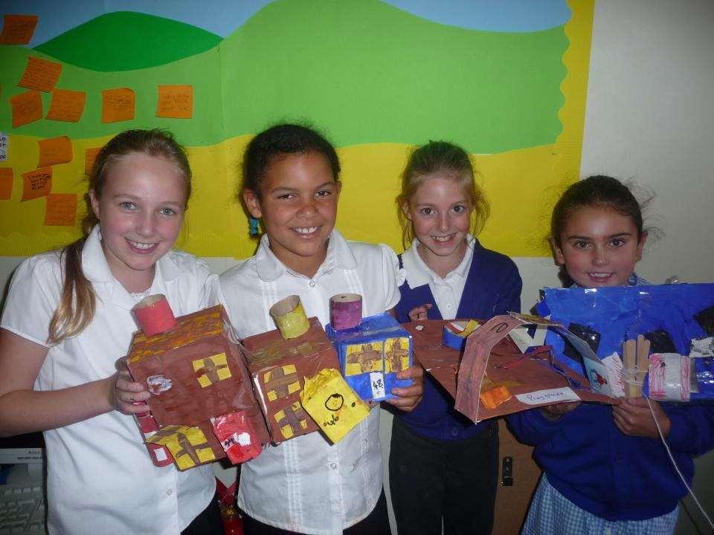
Head teacher Jackie Beech was keen that this should not be a one week wonder. She says: “We plan to revisit respectful RE though this year. We’re having an art project about open minds and we are continually keeping the week alive through class worship and assemblies. The children have been so thoughtful and mature. Also, following this week we advertised a series of "jobs" to give children opportunities to respect the school and have a sense of responsibility. All children were invited to become an eco warrior, or a friendship buddy, a school gardener or class room helper. We had 92 applications for the first round of jobs and more are coming in now. The children have really had to think about what special qualities they have in order to be chosen for the roles- the completed application forms are great and are on display.”

A PowerPoint sequence about this week of RE is available for download from the RE Today members’ website. See inside back cover of RE Today for this term’s password.

RE Today editorial group members loved this initiative:
Jane Brooke: “It is good to see pupils working and smiling together and growing alongside each other to think about an ideal community and create a street of respect for everyone.”
Lizzie McWhirter: ‘It’s a good example of excellence and enjoyment in RE: when year sixes work with year twos and the whole school goes off timetable for a week, providing a sense of community in the activity as well as the outcome.”
Chris Boxley: “It is heartening to see Dr Barnardo, a great philanthropist from an earlier era, picked up by the pupils. Barnardo wanted an ideal community, and so do these children. The dream of an ideal community, aspiring to a perfect community, is always there in human imagination. The vision these children translate is multicultural and promotes social cohesion, which Barnardo might not have said himself, but would recognise.”

Children’s learning:
Some pupils responded to the learning :
Jasmine: “Respect is treating others how we wish to be treated. By doing this everyone will be treated in a fair way and then those people will show respect back to me.”
Anup: “We show respect to people who help us, such as doctors, teachers and the lollypop lady. All of these people are doing something that makes our lives better so we show respect to them.”
Lucy: “I show respect to the environment by recycling at home and at school. The environment is special and beautiful so by recycling I am showing respect to it and making sure it lasts.”
Kim: “Respect is listening to my friends and other people when they are talking, this is so they know that I listen to their thoughts and they are valued.”
Chloe: “When we began to think about respect more deeply, we began to realise that it is not just actions, it can be seen in the world around us through our key concepts like peace, harmony, kindness, conflict, faith and hope.”

Example Three: A Creation Week
Wilby CE VA Primary School / Whole School RE project
Aim of the project
The aim of the whole school RE project was to develop the children’s spiritual awareness and to help them think about how their actions affect other people and the world in which we live in. During the week the teachers encouraged questioning; the children to ask each other questions as well as staff which aided deep learning. It also encouraged collaborative working between the children as well as foster the links we have with St Mary’s Church.
Objectives
- To know the story of Creation from the Bible in detail
- To ask questions about the story to encourage deeper thinking
- To respond to a topic in a creative way (poems, role play, paintings)
- To know the effect that their behaviour has on the environment

The Creation
How the glistening water reflects
The heating orange sun,
How the magnificent blue sky
Turns to peach pink,
The sun begins to set,
A brown stone covers the sun.

The Northern Lights.
A green light gliding through
The midnight sky,
How the frost covers land,
The water reflects the green tinted sky
And a shadow of a rock.

The deer.
Surrounded by pink blooms,
Smothered with green grass,
How its brown coat with white spots
Never blends.

Humming bird.
Vengeful, as it looks so innocent
But only catches a small lunch.

Earth.
It is like a ball of blue paint
With green and white,
Then God put it in the centre of the Solar System.

Butterfly.
It is as its wings
A delicate little creature,
Wings smooth,
Blue, white and black,
Special in a way.

Fish.
They feed us and other creatures,
They are relaxing to look at,
All types of fish
Are beautiful.
Us.
We are all very special,
And lucky that we were created,
So let’s be thankful.
By Gemma Thorpe

Two weeks ago, Wilby School did a variety of fun activities to do with the creation of God’s wonderful world. They enjoyed it a lot and had a great time. All of the children participated in this creative RE week.

Firstly, we listened to an assembly by Mr Murphy, a helpful governor. He told us the story of creation from the Bible with the assistance of Mrs Groom, who made a grand PowerPoint to go with it. After that, we went into our classrooms and our teacher told us the creation story again.
Then, we were put into groups of eight and we had to make a storyboard of creation.
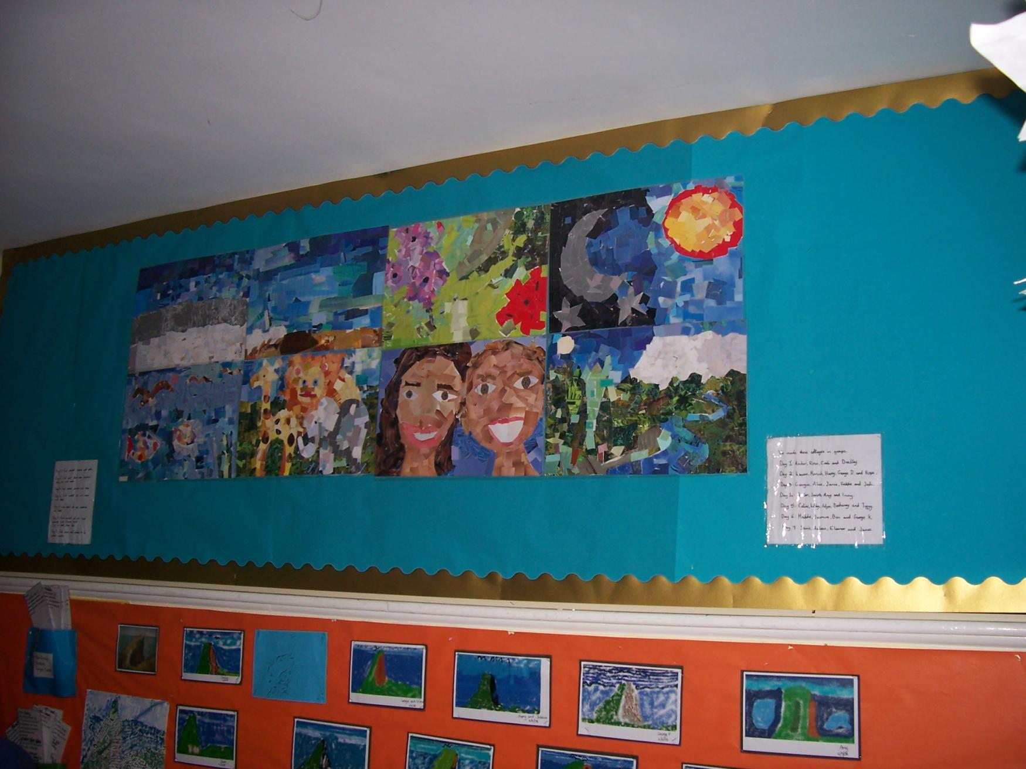
Each person was given a day to draw and the eighth person had to do a fantastic title. When we had finished drawing, we got to paint our pictures, when they were finished, they looked marvellous!
Next, we went up to the ICT suite with class three and Miss Gerrard had blackened the room. Then she lit a candle and we had to imagine what it was like when God first created light. When we came back downstairs, we had to choose which day we thought was the most important and write why.
The next day, we watched another PowerPoint about creation, created by our teacher, Mrs Griffiths. Then we had to write an outstanding poem. All the teachers were very impressed, and praised the children for putting lots of effort into their work. After lunch, we walked up to the church and looked at the trees, because each class had been asked to make a tree in one of the four seasons, spring, summer, autumn and winter. Our class had to do spring. We had clipboards with pieces of paper and pencils and we had to sketch a vast amount of trees.
On Wednesday, we made the class tree; we spent the morning making leaves. We had tissue paper and crayons and we had to rub the pattern of the leaf onto the paper. Some children were chosen to go up to the ICT suite and write some amazing facts about animals. Some people also finished their colour charts which we started on Monday, we had to colour in lines from dark to light and then we wrote feelings that the colours gave us.
On Thursday, we watched another PowerPoint about creation but in the style of an artist called Kate Neal. Her paintings showed her impression of the earth being created. Next we had to oil pastels and chalks on the tables, and we had to draw a picture of one of the seven days it took God to make the world, but in the style of Kate Neal. After that, we had to draw the earth with oil pastels and write what we would put into it and take out, like take out sadness and put in happiness. We also finished our titanic class tree for a display in the hall.
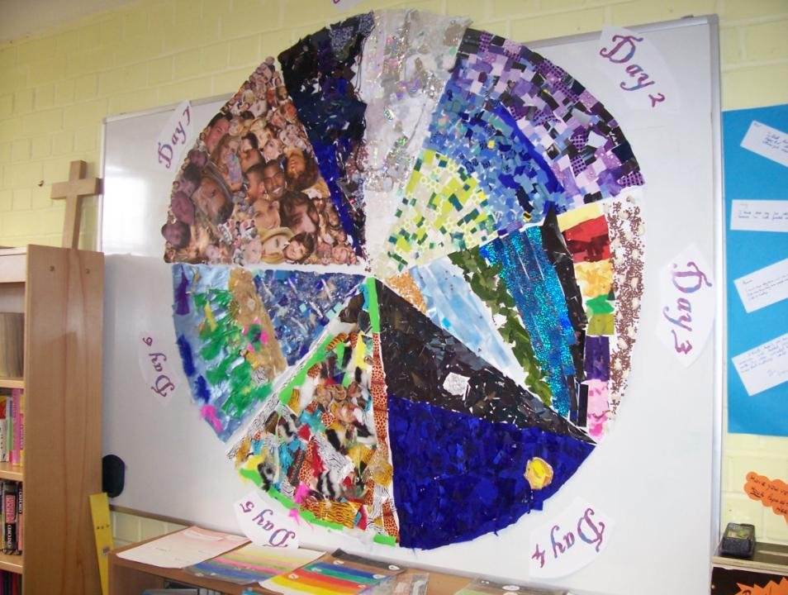
On the last day, we had to make a huge class collage to represent the seven days. We were put into groups of three and each group had a day to do. We were not allowed to draw because we were doing the collage in abstract style. We had to stick lots of different bits of material onto a big piece of paper cut like a pizza slice. Then when they were all finished, we put them together to make a big circle like the earth. When all our work was finished and displayed, our parents came in to have a look round, tea and coffee was offered to them to. Lots of the parents thought all our work was breathtaking!
We said “The best day was Friday, because we made the great collage, which was really good fun!” We interviewed some children and one said, “I had lots of fun and I liked it because it was a change!”
“I loved doing the Creation week because we don’t normally do things like this and it’s a chance to learn about God in a fun way!”
“I thought the Creation week was fun. I didn’t really like R.E but now I love it. I have taken an interest in it.”
By Molly and Antony: “We hope you enjoyed reading about our creation week!”

A Creativity and Creation Week Timetable
 | Monday | Tuesday | Wednesday | Thursday | Friday
Assembly | Ask a governor to come in and tell the children the story of creation from Genesis and why they feel it is an important story. | Drama of Adam and Eve, made up and done by Y6 on Monday PM – key parts for snake, Adam, Eve, voice of God | Hindu Creation story told to all children, drawing out the similarities and differences.  Giving Thanks – prayers and meditations written Tu PM | At the Church – children registered there. 2 singers from church come + sing ‘All Things Bright…’+ ‘Wonderful World’ + get the pupils singing too. Plan displays for Church | Pupils show some work they have been doing to the rest of the classes – Thursday PM preparation to speak for children from each class.
Mornings | 4-7s Models. Children to make lego models of what they would have seen during the creation. Recap with them what happened on each day. Each class has a list of graded questions for each year group to discuss creation as a class / as a group (e.g. what would they have expected to see on each day / which day do they think was the most important day / what do people think the story means / why do some people not believe this story). Order pictures of the day which have been given / make a storyboard drawing pictures / use pictures from www.coloring.ws/creation.htm  Y4/5/6 make ‘Seven Creation Tables’ for Y1/2 to use later in the week. (Lat has a sheet for this) | 4-7s: Music and RE. Make mime / actions / music to go with a song Look at some of the pictures / storyboards which they made yesterday. Ask them to question each other about what they think they would have been able to see / hear / taste / touch / smell on Day 7. Children to write a sense poems  “I can see…. I can hear…”  Y3 4 Rest: explore what happens when you rest. Learn about Shabbat  Y5 6 do ‘Temptation Sculptures’ from the Adam and Eve stories and do work on temptation in their own lives, looking at lying, kindness, bullying, pleasing parents, trying hard etc. Links to literacy. | 4-6s Animals we love best. Look at Day 6. Discuss the animals which may have been made. Children make animal masks. Role play what they could see / hear etc on the day they were created.  7-11s The most amazing animal in the world… Explore wonderful things about creatures e.g. seahorses (men give birth), squid (they squirt ink), chameleons (they change colour). They make 2 creation collages, one for birds and fish, one for animals (Day 4, 5) Poems called “The most amazing things about this world are….” Literacy links – Formal Debate: what is the most amazing creature on earth? | 4-7s: Forest School Activity: Out in the forest, the children create, in groups, seven tableaux of the days, 4 scenes from the Hindu Creation story, and a garden of Eden  7-11s: Pastel Art for Day 6. Show the children the first 5 pictures painted by Kate Neal, one at a time. Discuss each picture using the key questions in the teacher book “Picturing Creation” What do you think the artist wanted to show?  Ask children to speculate how Kate would paint day 6, and they create their image from the text in paint / pastels / colour. Mount an art gallery of results. | 4-5s Creation Walk  5-7s 4 Seasons, & Days, The Lotus and the gods and goddesses: Children to make the class collages, getting ready to do the display in the last session. Also creation cookery – making people, animal and star shaped biscuits for this afternoon.  7-9s Whole School Book, photos sets and video, writing, poetry and so on that collects everything from the week into books. Video box collects recordings of each class using tiny blue camera.  9-11s: Arguments in RE. Dramatising a debate between Hindu, Christian and Atheists about whether God made the world or not – scripting, persuasive writing, literacy connections.
Afternoon | 4-7s: Focus on Day 1 Dark and Light .Recap what happened. Darken the room. Discuss what it is like etc. Light a candle. Discuss what impact it has, what it looks like, how it makes them feel. Children to complete a colour chart using paints ranging from one side which are light progressing to those on the other side which are dark. Look at the colours and discuss how these represent feelings.  7-11s: P4C session – what would you like to ask about the story? Community of enquiry, mixed ages. Small group plan drama for Tu Assembly | Environmental ideas: Look at the models of creation that they made on Monday. Smash one up! (or one you have made) Ask them how they feel to have their creation spoiled. Now ask them to think about how God feels when he sees what we have done to his world. List an alphabet of ways the world gets spoiled. Children to use papers / magazines to make a collage to show good / bad things in the world.  Suggested Book  Gods Wonderful World by Nick Inkpen  7-11s: Solutions. How can people ‘save the world’? Greenpeace focus. | Y1 / 2 Visit Y5/ 6’s ‘Seven Creation Tables’ and do the reflective activities. Day 3 Look at the life cycle of the tree. How do the trees/leaves change over the year. Everyone to go to the field and take photographs of the trees / leaves. Collect some and bring them back. Each class to make their own tree (Allocate a season to each class)  Y3 / 4: learning about Hindu stories, gods and goddesses and the idea of creativity and destruction (Story of Brahma and Vishnu) | 4-7s Class Collages  The class to produce a collage about the whole creation story. Decide as a class what would be on the collage and then allocate different parts to each group. Children to plan.  7-11s, chosen group work. PowerPoint / Prezzie / Drama-Dance / Chanting: Pupils choose creative groups to bring the week’s work to a creative conclusion. Hindu and Christian shared in all media. | Exhibition – parents, family invited to view the children’s work.  Creation biscuits and drinks served  After school, work moved to the Church for a shared service on Sunday – parents invited.  Some Y5 children helped to make it into a gallery)  Christian and Hindu visitors  Press?

